Database change request process/flow

- Communicate the change to BI Team Engineer
- Create SQL script, test it on your local db instance and review with Server Team Engineer
- Submit SQL script into your Git branch under /server/database/changelog/<schema>/<Jira-Issue-ID>/

Detailed guidelines by examples:

- Update table data in cn_service schema as part of SRV-235:
1.Get Jira-Issue-ID: | 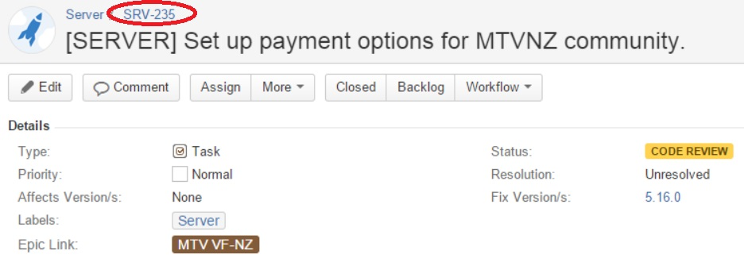  For example it gives you SRV-235
2.Create a folder in /server/database/changelog/cn_service/SRV-235  and submit the sql script: |  | 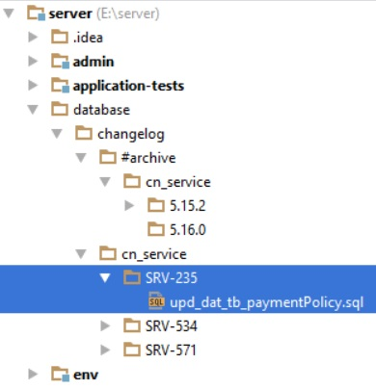
- Test DB:
TODO provide script to execute DB issue against sandbox schema e.g.: deploydb.sh –jira SRV-235
TODO create changelog table to keep track of deployments e.g.:

select * from changelog order by create_date desc;
ID | ISSUE_ID | FILENAME | HAS_ERRORS | PATH | CREATE_DATE
1 | SRV-235 | upd_dat_tb_paymentPolicy.sql | N | database/changelog/cn_service/SRV-235/upd_dat_tb_paymentPolicy.sql
2 | SRV-XXX | cr_tab_some_new_table.sql | E | database/changelog/cn_service/SRV-XXX/cr_tab_some_new_table.sql

Further Guidelines

Naming scripts: cr_tab_table_name.sql – create table, alt_tab_table_name.sql – alter table, upd_dat_table_name.sql – any modifications to table data.

- Before you merge your feature/<branch > into feature/current_release:
  - Go to JIRA and set Affects Version/s attribute of the related DB Jira issue.
  - Deploy your DB Issue to Potato & Cucumber DB instances

- Before branch-out of feature/current release: /server/database/changelog/ folder contents will be moved out into /server/database/changelog/#archive/<release_affected_version> folder to keep the current changelog short. TODO create Jira Report to list all DB issues by Affects Version/s attribute e.g.:
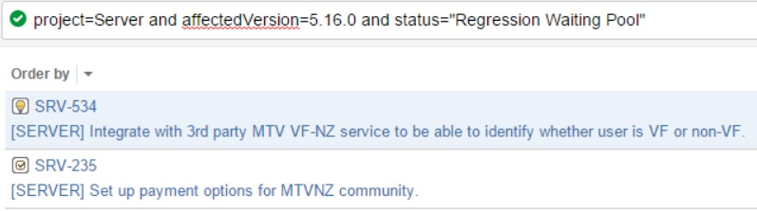

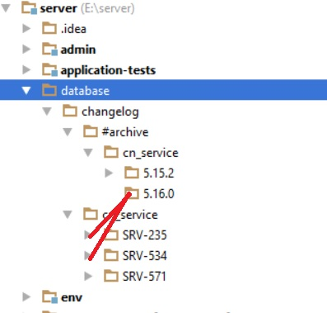

Note that SRV-571 DB issue is not part of next (5.16.0) release according to JIRA report and thus should not be moved to #archive/5.16.0!

- What about non-backward compatible changes? Work with the Team to find the ways to convert your non-backward compatible changes to become backward compatible. In case the is no way, consult this to BI and DevOps to get your database change reviewed. If you both determine the change will break the previous release then create a “rollback” folder in the BD issue folder. Rollback folder shall contain rollback script which will rollback the change to previous release! Do not create rollback folder if the change is backward compatible or in case of application rollback we do not want to rollback the change.

- What about clean up schema changes? If applicable (e.g. in case of db table column renaming) create new Jira Task and submit SQL script to Git to do required db clean up. Plan Fix Version of the created task with the Team!

- What if I have more files for one DB Issue and they depend on order of execution?
Create deploy.sql and call the sql files in correct order. See example below.

- Extreme case: Dependency between DB changes: What if SRV-534 need to be executed before SRV-235? Rename SRV-235 folder to be SRV-534_ SRV-235. Basically prefix the SRV-234 with the SRV number on which it depends.

If SRV-235 depends on SRV-534 then no action is necessary.

TODO: create auto deploy tool which deploys database changelogs in alphabetical order.

- If a DB issue is not supposed to be deployed automatically with complete release but manually by Ops at a specific time, then put a comment into the sql script with this format:
--MANUAL DEPLOY

